**Master Functional Document**

|  |  |
| --- | --- |
| **Application** | NGERP - Centra |
| **Service Bundle** | Master Management |
| **Service Request** | Lot |

**Description :**

Lot Master is used to view the created lots from material receipt. User can able to view if the lot is active and its created and expiry date in the Lot master.

**Workflow Process :**

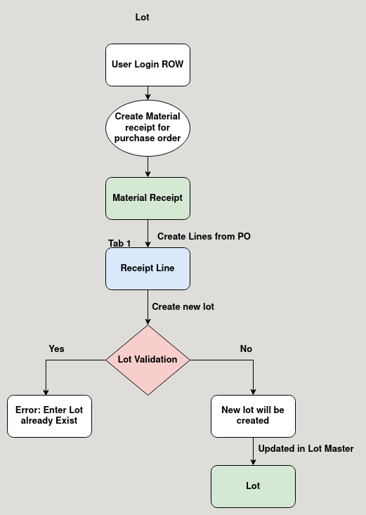

**Business Rules :**

* User Login as Region to create lots.
* New Lots can be only created in Material Receipt and Stock Take Adjustment.
* Lot is a storage area inside locator to store products.
* User can create new lot or choose existing one to store the purchased product.
* Every lot name should be unique.
* User cannot create a new lot if there is already an existing one.
* The expirey date of the lot should be given when creating a new lot.
* The expiry date of the product is the expiry date of the lot.